REGULADORES DE VOLTAJE 3,3V PARA ELEGIR

MIC5205 PRECIO: $1.666 https://www.sigmaelectronica.net/producto/mic5205-3-3/

DATASHEET

https://www.sigmaelectronica.net/manuals/MIC5205-3.3.pdf

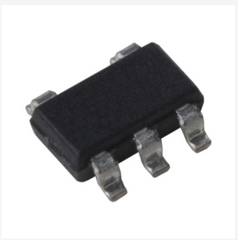

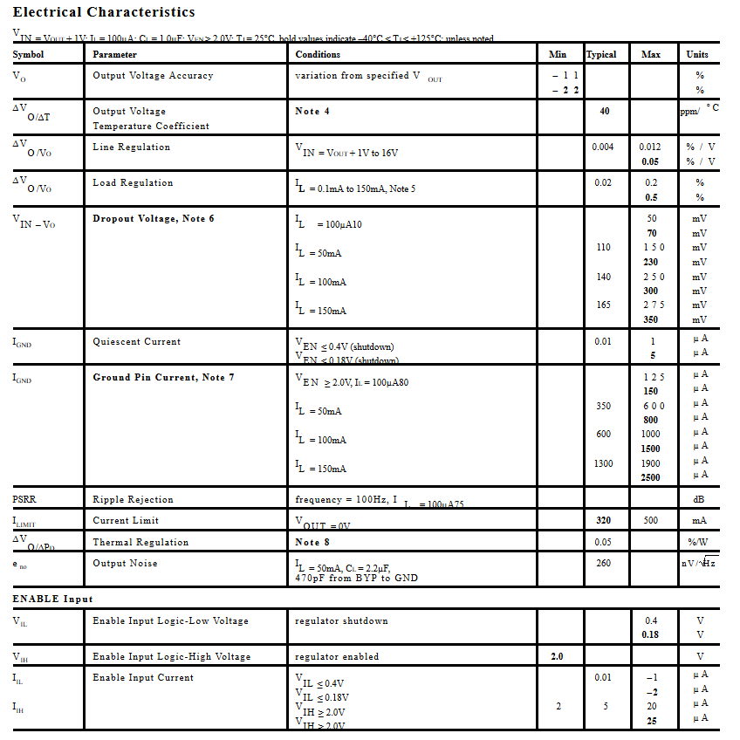

NCP1117LPST33T precio $714 pesos <https://www.sigmaelectronica.net/producto/ncp1117lpst33t/>

DATASHEET

https://www.sigmaelectronica.net/manuals/NCP1117L.pdf

